Advanced Predictive Analytics
Mid Term Exam, Fall 2014
Total Marks = 40.
Time: 1 hr 15 mins.

Answer each problem in the space provided; use the back of the preceding sheet in extreme conditions only.
Declaration: By submitting this examination for grading, I affirm that I have neither given nor received help from another examinee.

Name: ________________________________

Signature: ________________________________

Q. 1: [ 10 pts total]
(a) )(3 pts)Suggest two ways of avoiding overfitting when designing a decision tree based classifier.

use cross-validation to prune the tree (splits that result in increased error on CV data are removed)
keep a minimum requirement on the number of instances at a node before it can be considered for a split.
Have an apriori set limit to total number of splits and/or depth of the tree

(b) (2+2 pts.) Feature selection is a special case of (linear) feature extraction while PCA is a linear feature extraction technique with certain optimality properties.
(i) In what sense is PCA optimal?

PCA Maximizes retained variance (among all linear projection onto a subspace of a given dimension). Equivalently, minimizes reconstruction error (measured by squared loss) among all possible linear projection and subsequent linear reconstruction methods.

(ii) Why may one prefer feature selection to PCA in certain situations for pre-processing the data for a classification problem?

Retains original fealtures, hence more interpretable.
Reduced data collection requirements going forward. (since PCA features are derived from the full set of features, in general).

(c) (2+1= 3 pts) Why is it undesirable for (any) two input variables used in a linear regression to be highly correlated? Suggest one way of dealing with this problem.

- collinearity problem, thus increased uncertainly (larger standard errors) in estimating the coefficients.
(note: this does not affect empirical MSE as such).
- Regularize using ridge, say. Will keep the coefficient magnitudes from blowing up, or transform using PCA so the new (derived) features are uncorrelated.
Q 2. (10 pts)
- (3 pts.) (Repeat!!) What is Multi-Dimensional Scaling?

Key is: projection of pairwise similarity/distance data to an (artificial) vector space of appropriate dimensionality so as to have low distortion between the similarity/distances in the original specifications and those that are obtained from the projected data.

(b) (3 pts) Briefly describe by what you understand by the “kernel trick” employed in a Support Vector Machine, and how this trick expands the capabilities of this classifier.

All inner products between pairs of (projected) vectors are replaced by a suitable kernel. This allows for non-linear classfier boundaries (in the original space) without explicitly mapping the original vectors into a high-dimensional space.

(note: this is not to speed up computation or to be able to work with high dimensional inputs).

(c) (2+2 pts). What are key computation intensive steps involved in the design and test of a decision tree? Suggest one way of scaling decision trees to very large datasets, emphasizing which aspects of this approach help to make it scalable.

(from homework 3, #4(a))

Q3 (total 10 pts).
(a) (2+2 pts)
The figure on the right pertains to the use of LASSO for a regression problem, with the curves showing the weights of different regression coefficients.  - What could the x-axis represent? (for your choice, mention if the values are lower towards the left or the right).  - Suppose the optimal solution is obtained for a value of “x” in the middle of the range shown in  the figure. In terms of model bias and variance, what can you say about another solution that  could be obtained by choosing a value to the right  of this “optimal” value? | 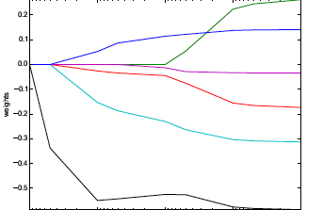

- either degrees of freedom (from low to high) or regularization penalty (lambda) from high to low.
- Right means less regularization, so
  - Bias decreases, variance increases
  - Sum of bias-squared and variance increases compared to optimal lamba value.

- (5+1 = 6 pts) Consider the Bayesian belief network below with the associated conditional probability tables.
(i) What is the probability that it rained given that it was a cloudy day but the grass is not wet? (give the arithmetic expression with numbers in it, but you don’t need to solve it to get the answer).
(ii) Given no information other than the network below, is it still possible to compute the probability that it rained? (just answer yes or no).
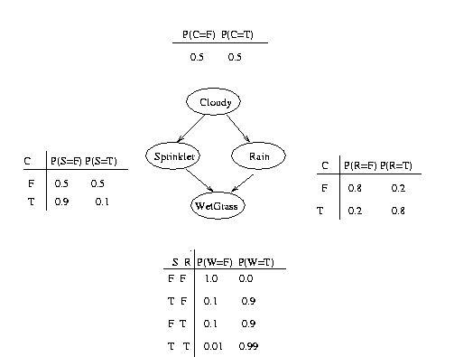

Q 4. 2 pts each. Pick any 5

- What is semi-supervised learning, and why is it becoming increasingly important for in predictive modeling settings involving large amounts of data?

Use both labeled and unlabeled (or highly uncertain labeled) data to build a data. More and more we are encountering situations where the amount of data available is large but much of it has no labels or highly noisy labels, e.g. relevance of search results, recommendations, spam filtering, …

(ii) What is Quadratic Discriminant Analysis?
see notes:
(iii) What is the use of the “slack penalty” in SVMs

allows formulation to extend to datasets that are not linearly separable.
Amount of this penalty provides a knob to trade-off between bias and variance.
(iv) What is the Huber loss function and in what situation(s) may it serve as a more useful loss function for regression models?

See notes: more robust to outliers.

(v) Suppose you are considering splitting at a decision tree node based on a categorical variable with L levels. How many distinct split points need to be evaluated? (state the answer with a brief explanation).

If nominal (e.g. red, green, blue…) 2^K possible subsets. But left/right symmetry and the empty (or full) subset is not useful.
So get 0.5 (2^k) – 1.
If ordinal, then K-1 splits as the levels are ordered.

(vi) What is an “epoch” mean when used in the context of training a multilayered perceptron (a kind of neural network)?

One pass over the training data (for SGD), i.e. N SGD steps if N is the size of training data.

Space for doodles, jokes etc.

